Configure Linux RHEL8 server and Install Oracle 23ai software
Create swap space on Linux server
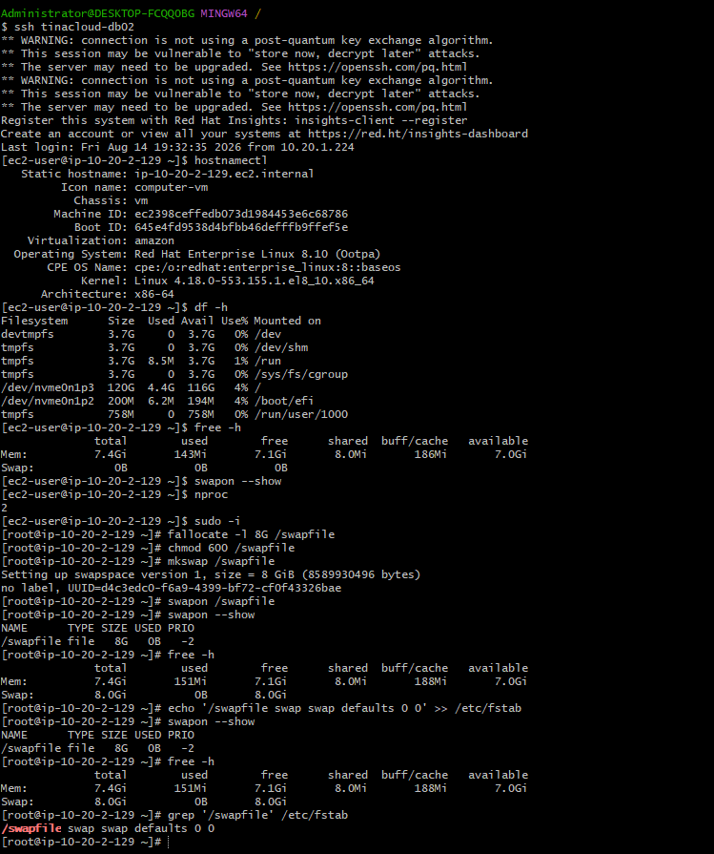

Install Oracle OS Packages and Libraries
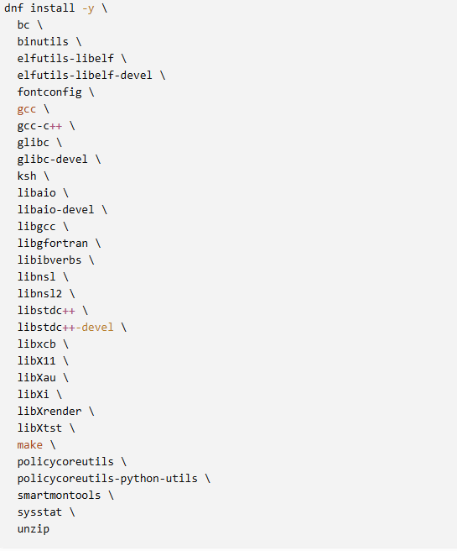
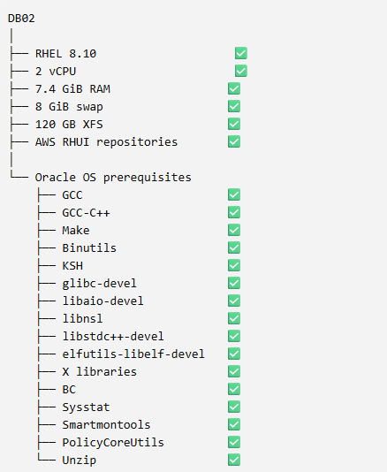

Check to see if any groups and users already exist, then create Groups and Oracle user if it doesn’t already exist:
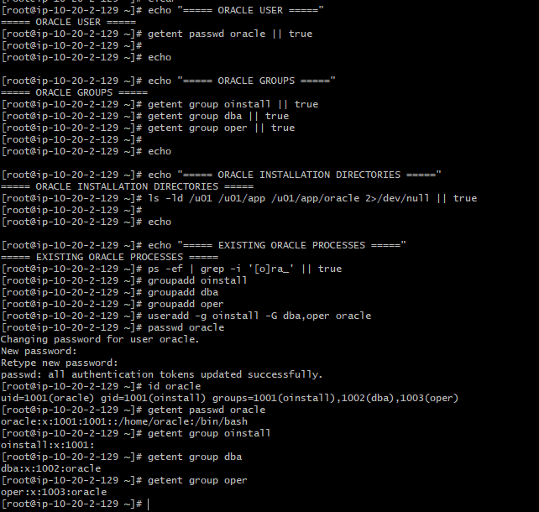

Create Oracle Inventory directories:
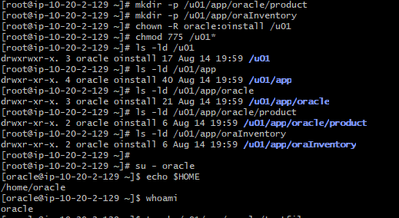
Check Kernel parameter and create Linux kernel configuration file
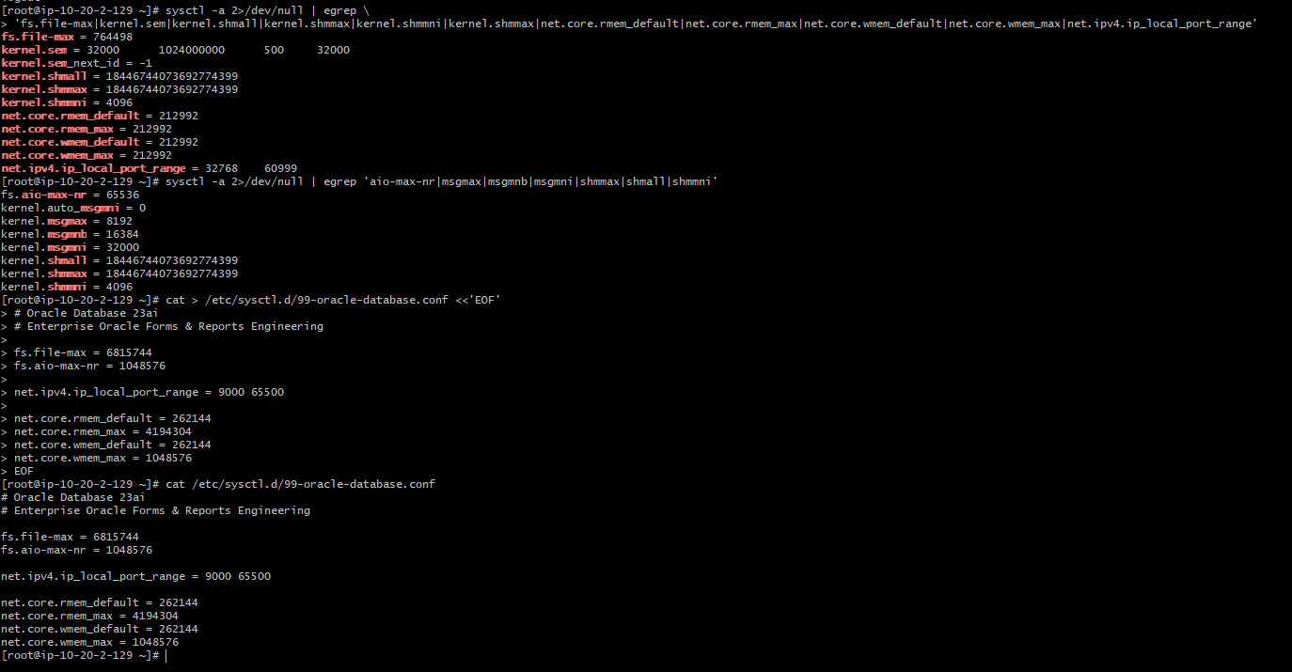

The kernel configuration was applied successfully and every value that was changed validated correctly.
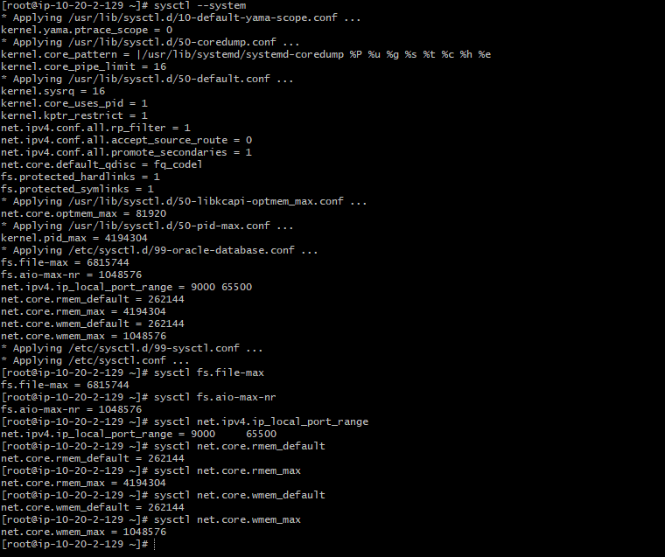

Hostname & Network Identity
-set hostname, add database server name in etc/hosts and ping db server from app server
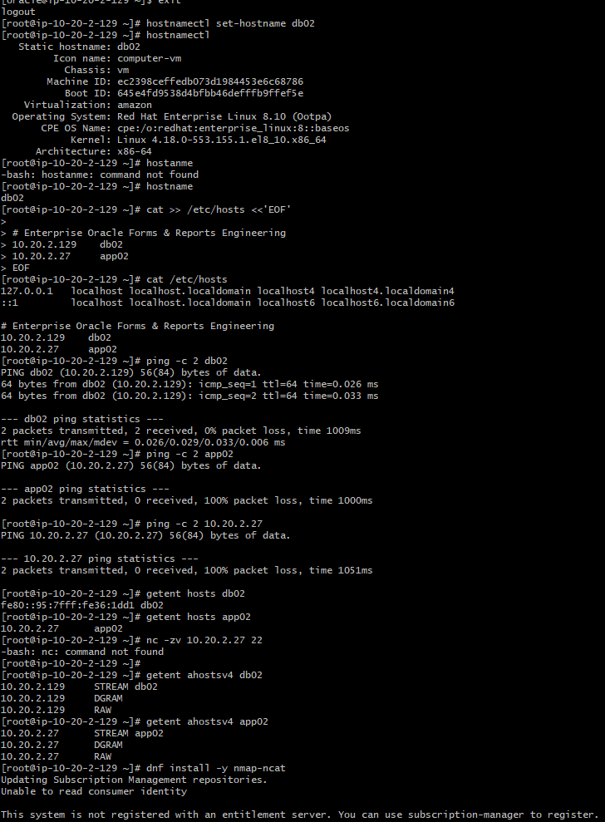
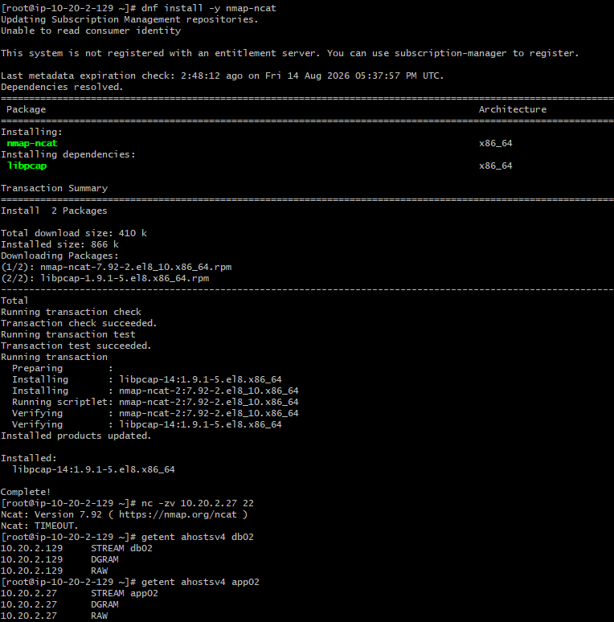

Install LVM and attach EBS volume:
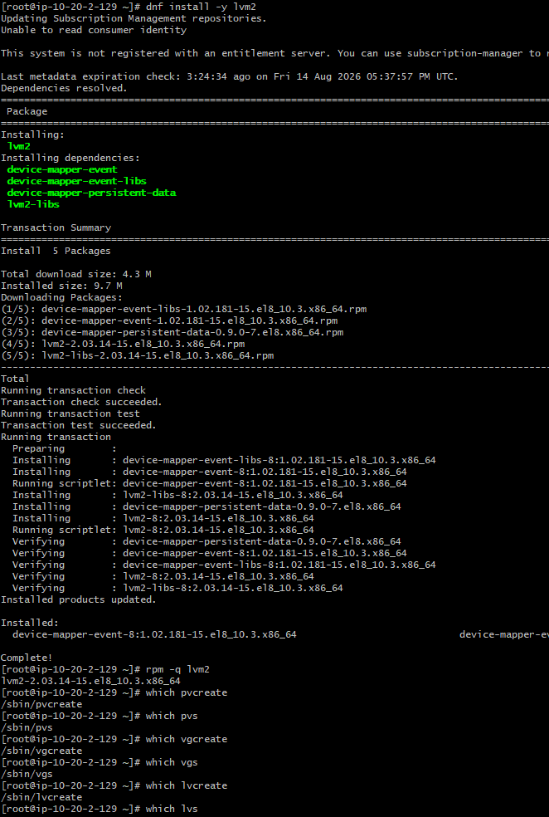
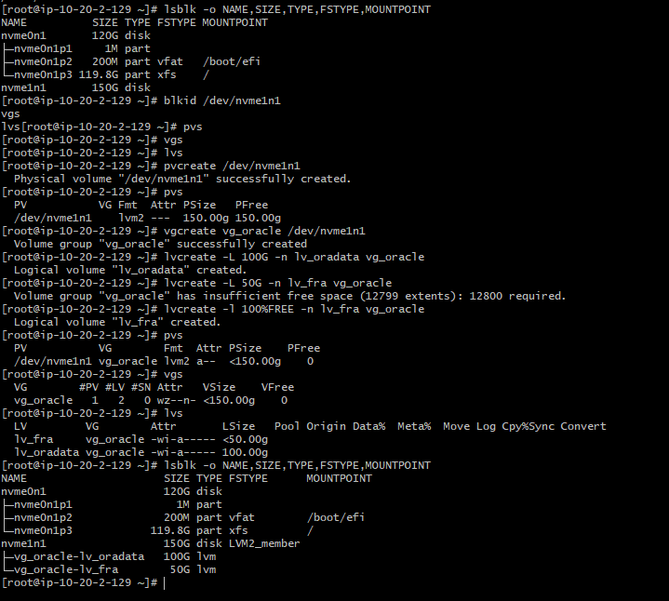

Storage:
Create XFS filesystems
-create /u02/databa and /u03/fra directories and Mount EBS volumes on them, give ownership on the directories, and make the data persistent by adding it to fstab file.
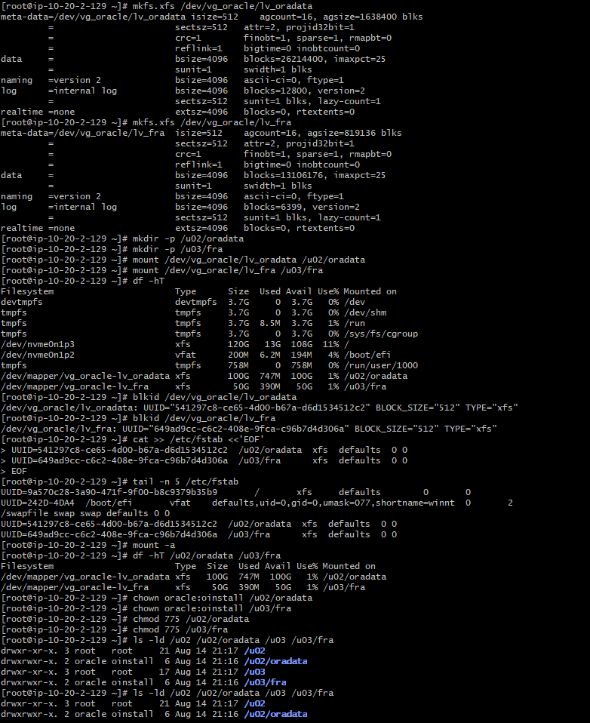
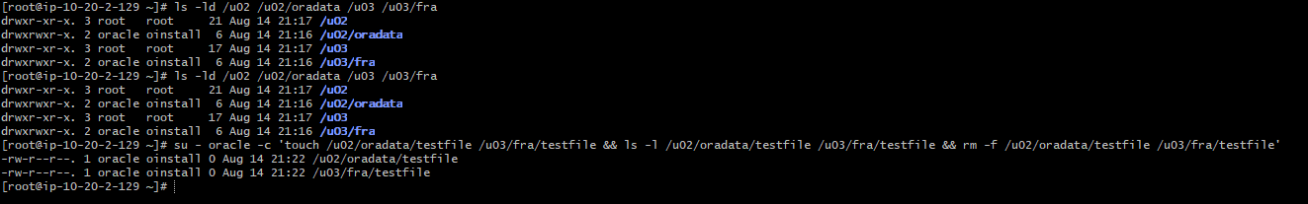
Copy Oracle 23ai software and stage it on /u01/software
- give ownership and permission
- create ORACLE_HOME and oraInventory on /u01
- test to unzip software on u01/software, if no issues then actually unzip it on 23ai oracle home.
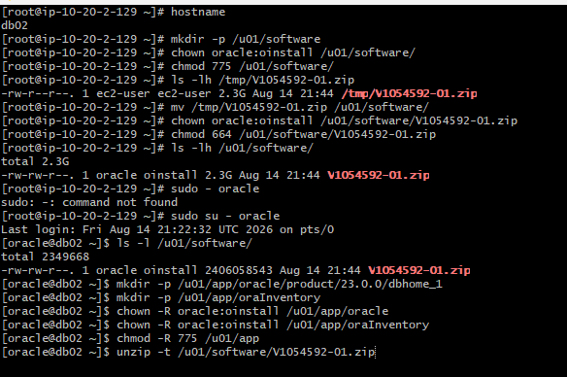
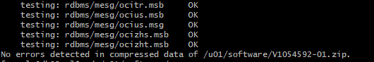
Unzip oracle 23ai on Oracle home: /u01/app/oracle/product/23.0.0/dbhome_1
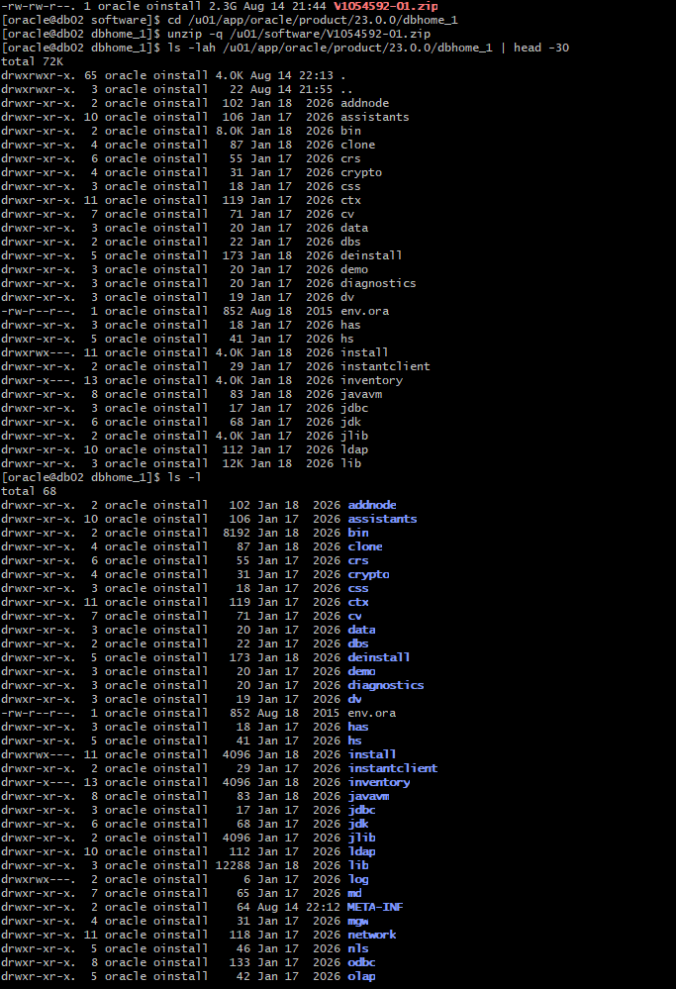
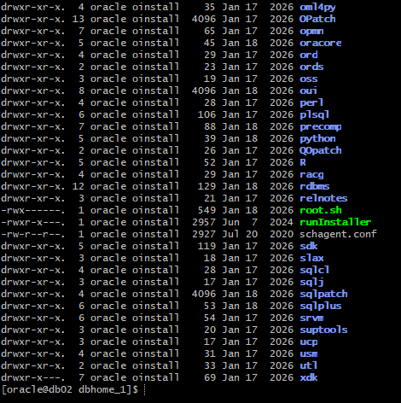

Oracle Home verification:
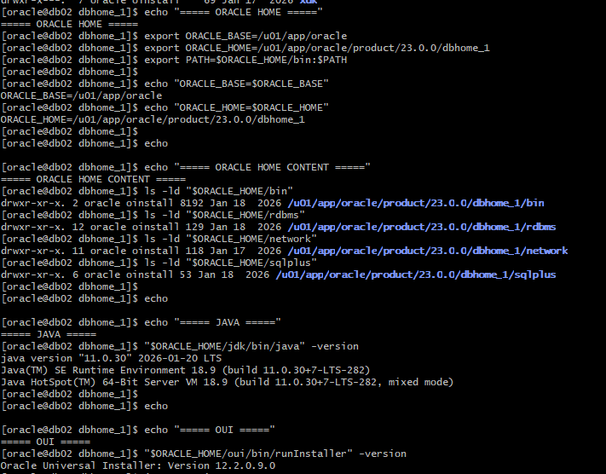

Edit bash profile with Oracle 23ai environment variables
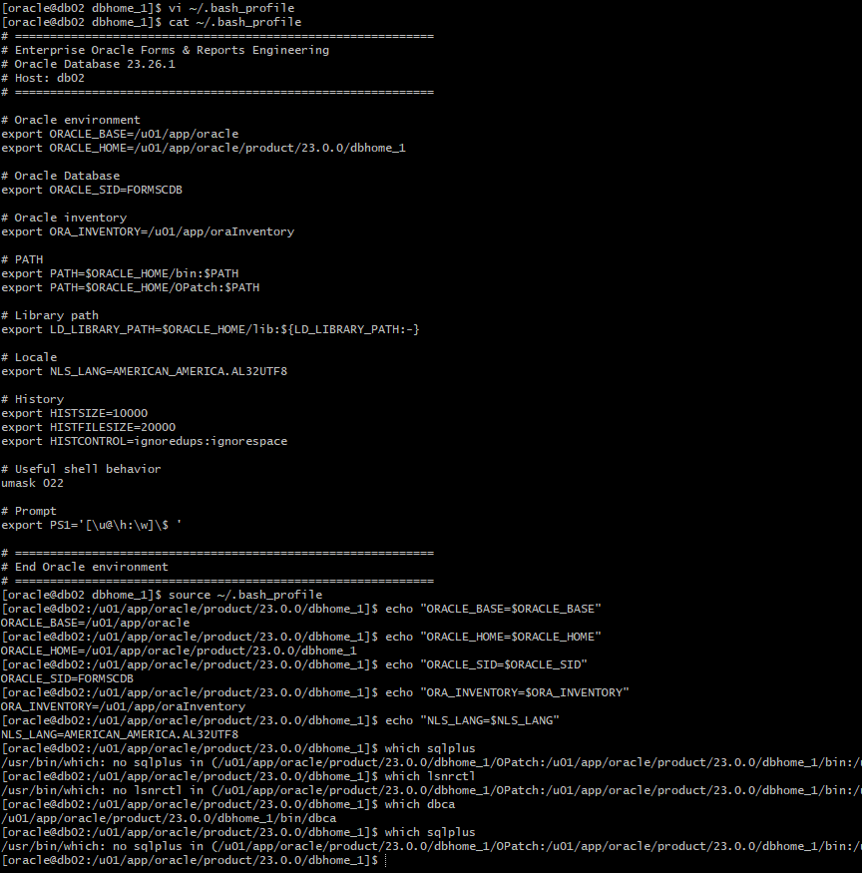

Execute ./runinstaller to install oracle software
Run post installation root scripts
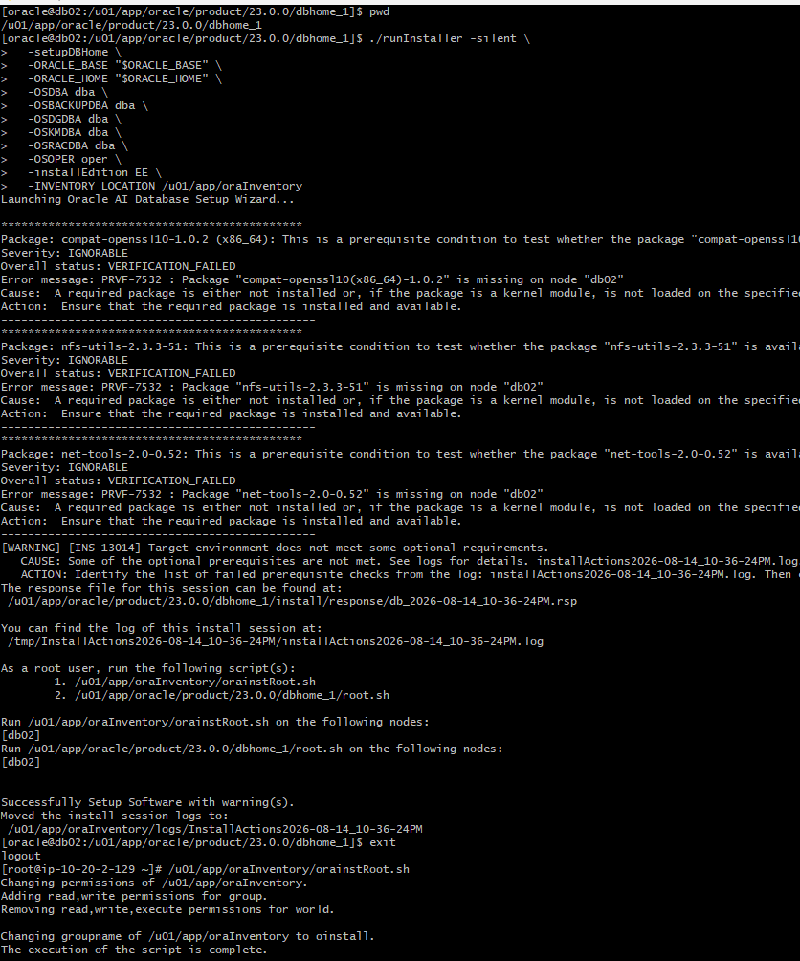
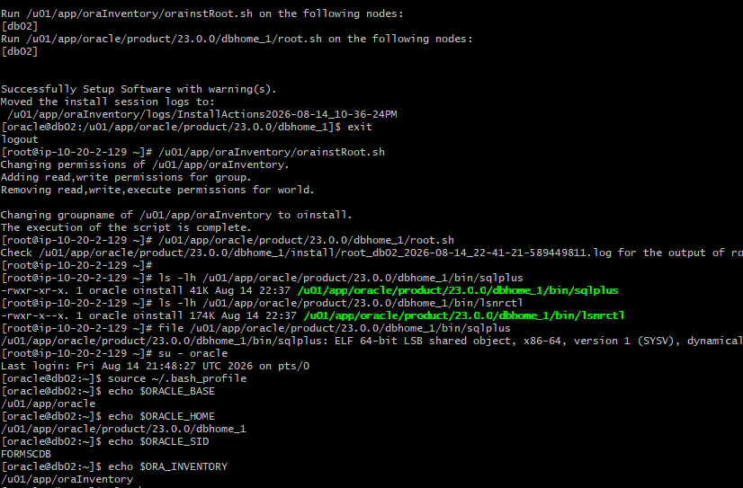
Configure listener and tnsnames.ora:
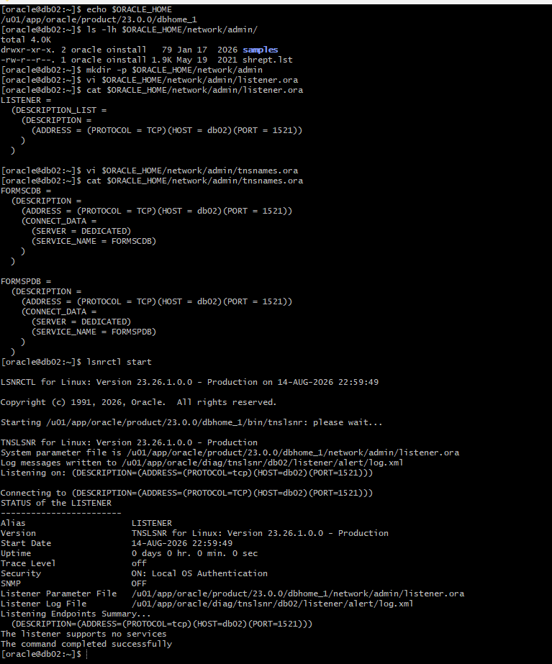

Create response file and use it to create CDB and PDB
